root@cyberster:~$
DAY 3 & 4 — WAZUH SIEM INSTALLATION
Deploying the Wazuh Manager, Indexer, and Dashboard on the Ubuntu Server VM
// 01 OBJECTIVE
Wazuh is the SIEM (Security Information and Event Management) platform that the SOC lab is built around for the rest of Phase One. A SIEM ingests log data from across an environment, runs it through detection rules, and surfaces events worth investigating. The objective for Days 3 and 4 was to deploy all three Wazuh components — Manager, Indexer, and Dashboard — on the Ubuntu Server VM using the official quickstart installation script, and to confirm all services were active before moving on to agent enrollment in Days 5 and 6.
Before installing, a static IP was confirmed on the Host-Only adapter, since Days 5 and 6 depend on agents pointing at a fixed manager address. The rest of this report documents the installation attempt, the issues encountered along the way, and the verification steps once the stack came up successfully.
// 02 PRE-INSTALLATION: STATIC IP VERIFICATION
The Ubuntu Server VM's Host-Only adapter address was confirmed before touching the installer. This is the address that the Wazuh agents (Days 5–6) and any browser session will use to reach the manager and dashboard, so it needed to be fixed and verified up front.
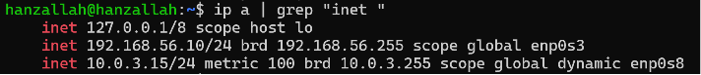
Figure 02.1 Output of `ip a` confirming the static Host-Only IP on the Ubuntu Server VM.
// 03 WAZUH INSTALLATION — QUICKSTART SCRIPT
$ 3.1 Fetching the installer
The official all-in-one quickstart script was pulled directly from the Wazuh package server rather than any third-party guide, to avoid version mismatches:
curl -sO https://packages.wazuh.com/4.9/wazuh-install.sh

$ 3.2 Running the installer
The all-in-one flag installs the Indexer, Manager, and Dashboard together on a single node:
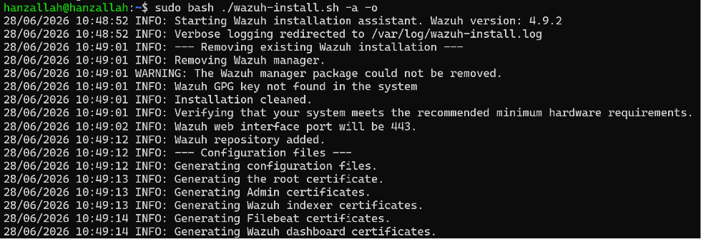
Figure 03.1 Terminal output showing the installer command and the start of the Wazuh indexer installation stage.
// 04 TROUBLESHOOTING LOG
The installation did not succeed on the first several attempts. Each failure pointed to a different layer of the system, and resolving them in sequence is documented below since this is where most of Days 3 and 4 actually went.
$ 4.1 Manager package left in a broken state
On more than one run, the Wazuh manager package showed as fully installed (ii) in dpkg's database, yet /var/ossec was missing from disk entirely. Starting the service failed immediately with:
/usr/bin/env: ‘/var/ossec/bin/wazuh-control’: No such file or directory

Tracing this back, the package's own preinst script was exiting before it finished unpacking files, because it tried to stop a “previous” Wazuh manager that no longer existed on disk. dpkg's bookkeeping and the actual filesystem state had fallen out of sync. The fix was to neutralize the broken maintainer scripts directly so dpkg could cleanly purge the package, then reinstall from scratch:
sudo bash -c 'printf "#!/bin/sh\nexit 0\n" > /var/lib/dpkg/info/wazuh-manager.preinst'
sudo chmod 755 /var/lib/dpkg/info/wazuh-manager.{preinst,prerm,postrm,postinst}
sudo dpkg --purge --force-all wazuh-manager

$ 4.2 Disk space exhaustion during dashboard install
Once the manager and indexer were installing correctly, the dashboard package failed partway through download with:
E: You don't have enough free space in /var/cache/apt/archives/.

The VM's root filesystem was only 12 GB, and the combined footprint of the indexer, manager, filebeat, and dashboard packages exceeded the remaining free space. The underlying VirtualBox disk was already 50 GB, so the fix was to grow the in-VM partition and LVM volume to use the space that was already provisioned, rather than resizing the .vdi itself:
sudo growpart /dev/sda 3
sudo pvresize /dev/sda3
sudo lvextend -l +100%FREE /dev/mapper/ubuntu--vg-ubuntu--lv
sudo resize2fs /dev/mapper/ubuntu--vg-ubuntu--lv
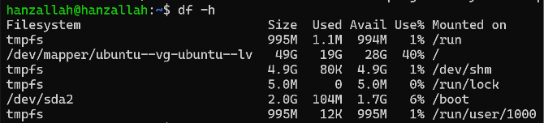
Figure 04.1 Before/after `df -h /` showing the root volume growing from 12 GB to 49 GB after the LVM resize.
$ 4.3 Orphaned indexer process holding ports 9200/9300
After purging the indexer package during one cleanup cycle, the underlying OpenSearch process kept running and held onto ports 9200 and 9300, which blocked the next install attempt outright. Killing the orphaned process freed the ports for the next run:
sudo pkill -9 -f opensearch
sudo pkill -9 -f wazuh-indexer

// 05 SUCCESSFUL INSTALLATION
With the dpkg state cleaned, disk space expanded, and stale processes cleared, a final run of the installer completed all three components without error:
sudo bash ./wazuh-install.sh -a -o
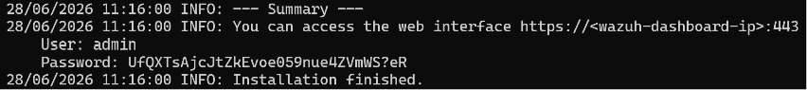
Figure 05.1 Full terminal output of the successful installation run, ending with the dashboard access URL.
// 06 SERVICE VERIFICATION
Each of the three Wazuh components was checked individually with systemctl to confirm it was active and running before moving on.
$ 6.1 Wazuh Manager
sudo systemctl status wazuh-manager
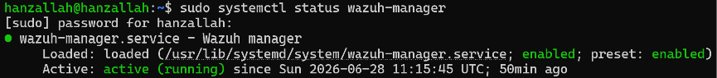
Figure 06.1 systemctl status output showing wazuh-manager as active (running).
$ 6.2 Wazuh Indexer
sudo systemctl status wazuh-indexer
Figure 06.2 systemctl status output showing wazuh-indexer as active (running).
$ 6.3 Wazuh Dashboard
sudo systemctl status wazuh-dashboard
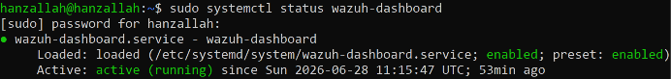
Figure 06.3 systemctl status output showing wazuh-dashboard as active (running).
COMPONENT | ROLE | STATUS
wazuh-manager | Receives logs, applies rules, generates alerts | ACTIVE
wazuh-indexer | Stores log/alert data in searchable form | ACTIVE
wazuh-dashboard | Web interface for investigation | ACTIVE

// 07 DASHBOARD ACCESS
The dashboard was reached from the Windows 11 host browser using the Ubuntu Server VM's Host-Only IP on port 443. The browser's self-signed certificate warning was accepted, and login was completed using the admin credentials generated by the installer in wazuh-install-files.tar.
https://192.168.56.101:443
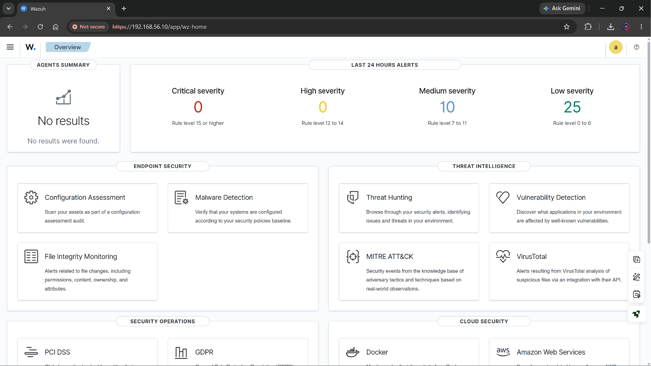
Figure 07.1 Wazuh dashboard successfully loaded in the browser after login.
// 08 SUMMARY
- All three Wazuh components (Manager, Indexer, Dashboard) are installed and verified active on the Ubuntu Server VM.
- The recurring manager install failure traced back to a desynced dpkg state from an interrupted earlier attempt, not a resource problem.
- The original 12 GB root partition was undersized for the full stack; resizing the LVM volume to use the already-provisioned 50 GB disk resolved the dashboard install failure.
- Static IP on the Host-Only adapter is confirmed and ready for agent enrollment in Days 5 and 6.
- Next step: explore the dashboard's Overview, Agents, and Security Events sections ahead of connecting the first agent.

